The site is opened by using the URL http://www.aicrip-intranet.in or directly accessible by clicking
the intranet link in ICAR-IIRR website ( https://www.icar-iirr.org ).
Login form is available in the home page. Enter user name and password allotted to your discipline and center and press login button to enter into AICRIP-Intranet .

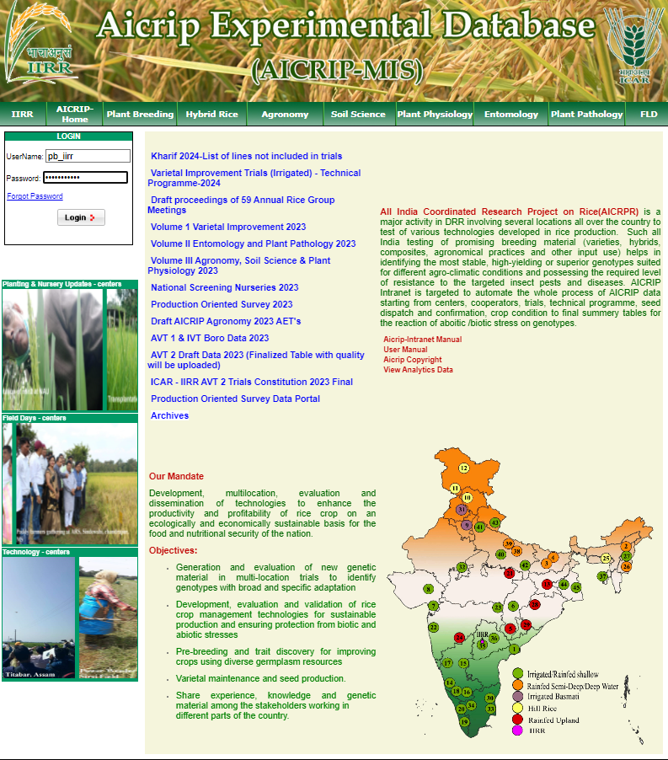

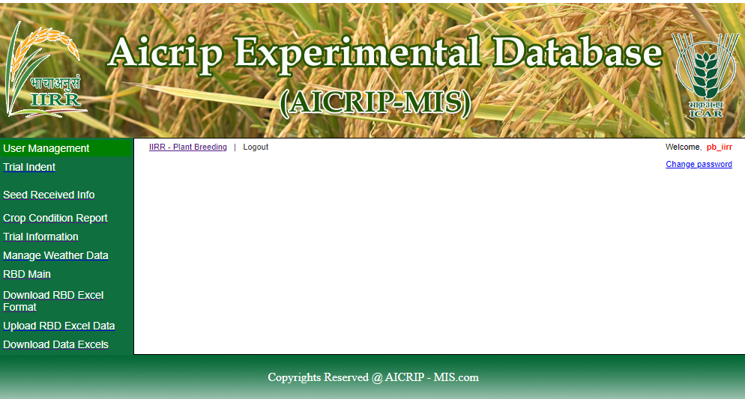

Change Password
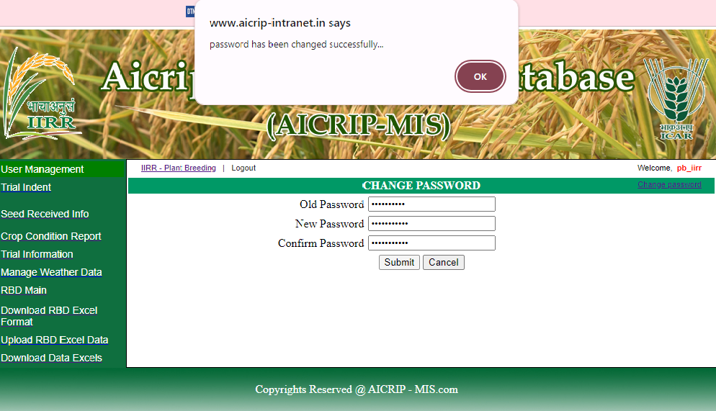



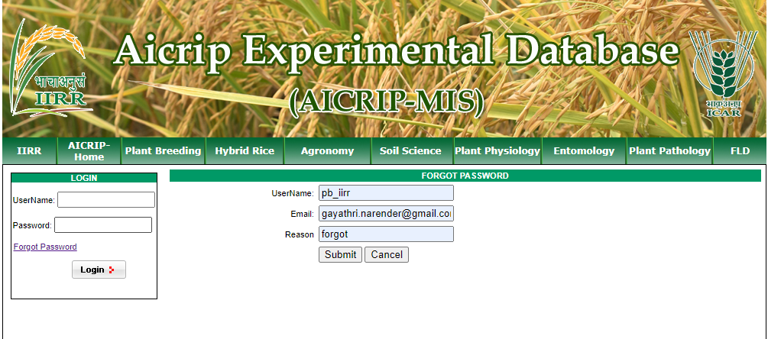

Choose RBD Main from the left side menu
RBD Design

Trials with RBD design will be entered using RBD Main menu item. Use Add RBD Click Here (follow the arrow mark given below) to enter RBD data.

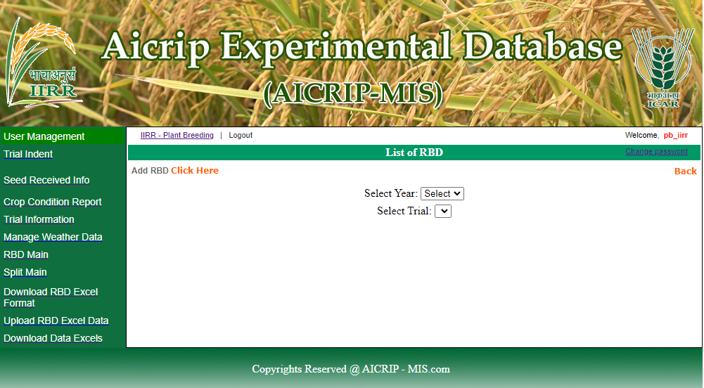
First Select Year and Trial from the respective drop-down boxes as shown in the following screenshot . Then Parameter Name field will be displayed along with number of treatments and number of replications. Select one parameter and press Add button to get grid for entering replications and treatments.

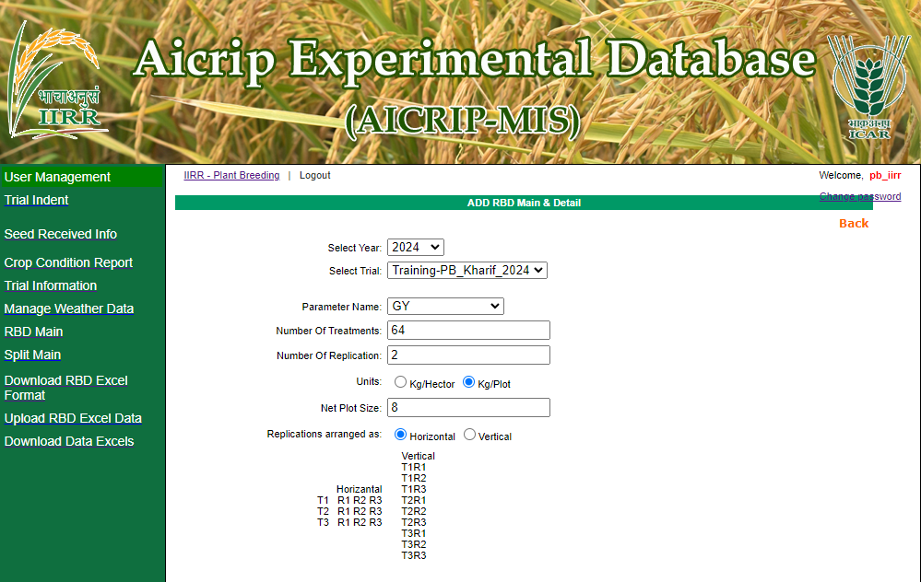
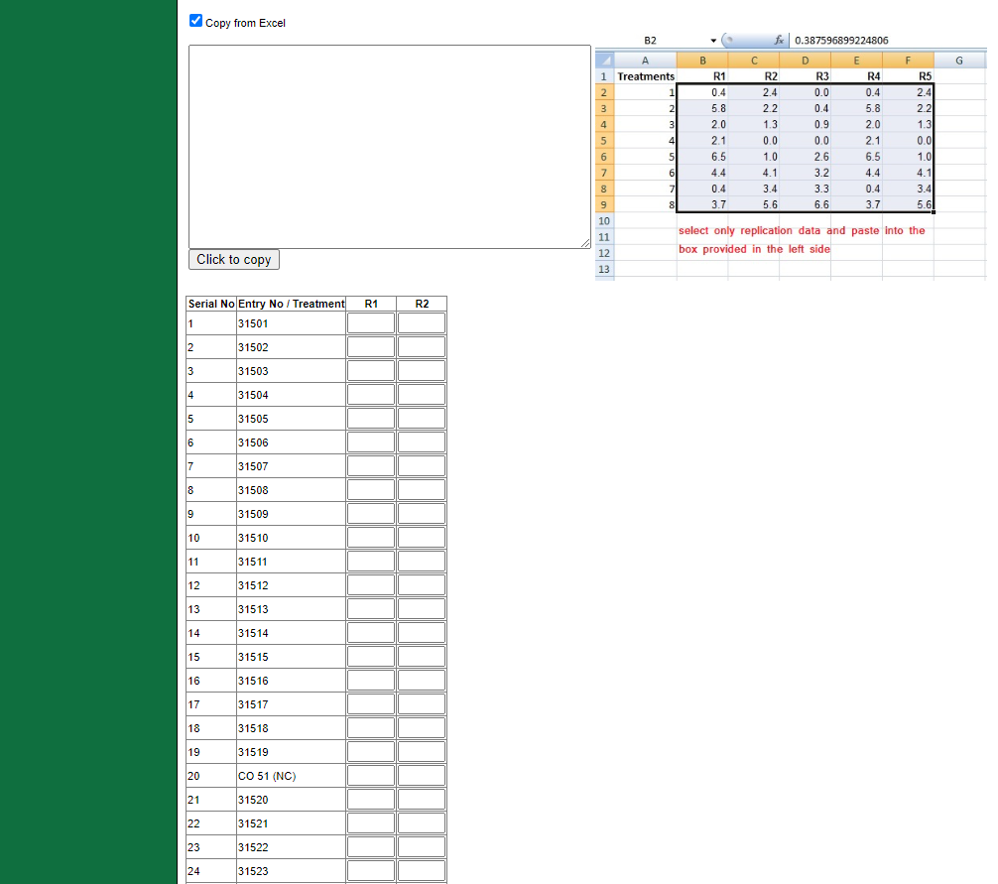

Grid will be displayed along with the entry numbers for the entered replications and treatments. Check Copy from Excel option to copy the data from the excel and paste into the empty space and click on Click to copy button to paste the records into grid.
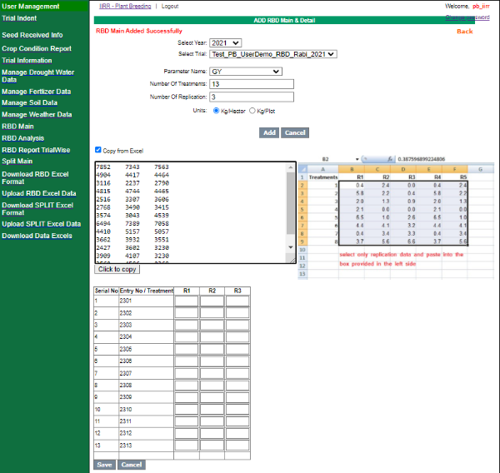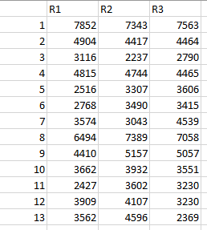
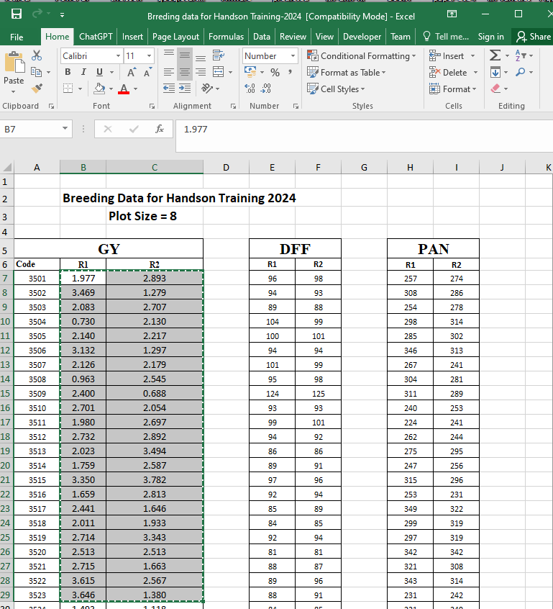
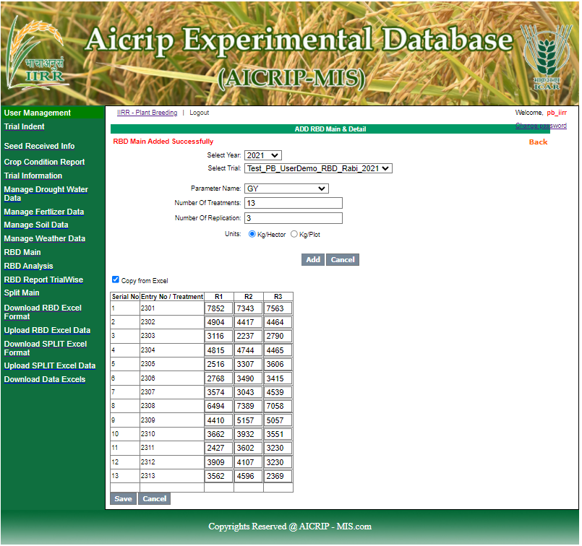

Then click Save button to save the data. User has to use these three buttons to copy, paste data from excel and save data in centralised server. Then your data will be saved and you can also view this data using View button

View screen
View update screen

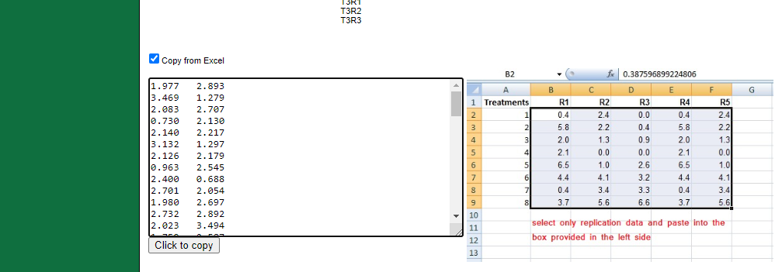
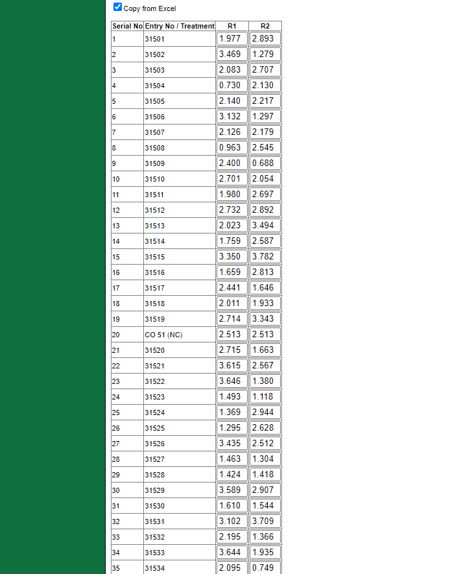

If any corrections are there in the data, you can modify the data in the view interface or again you can copy from excel and paste it in the grid to correct the data and use Update button to save the data in the server database.

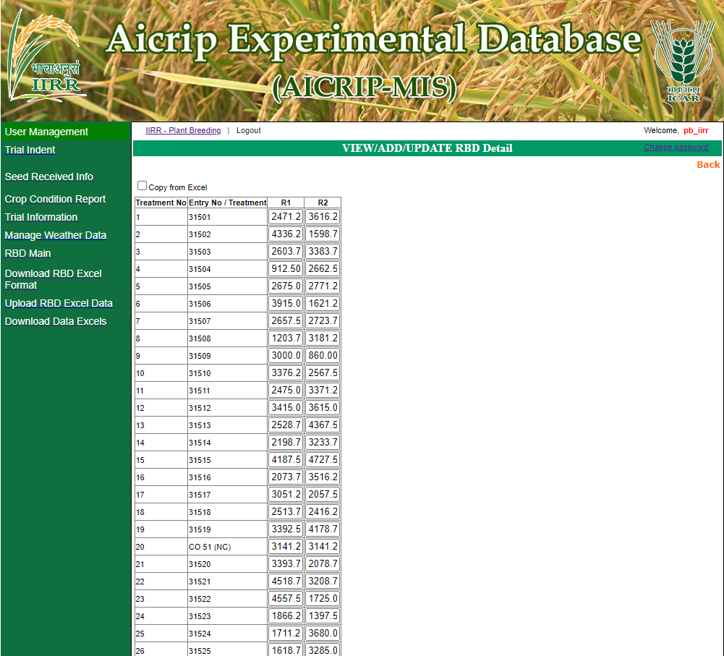
Manage Weather Data
Day wise weather data can be entered using Manage weather data menu item. Click on Add Weather From Excel from the top left corner of the menu after the banner (Please follow the arrow mark).

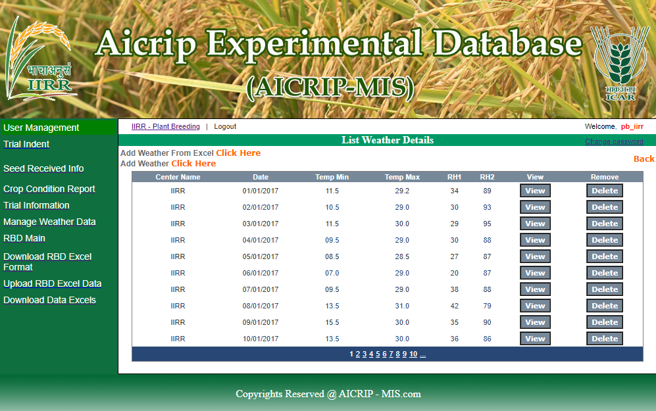
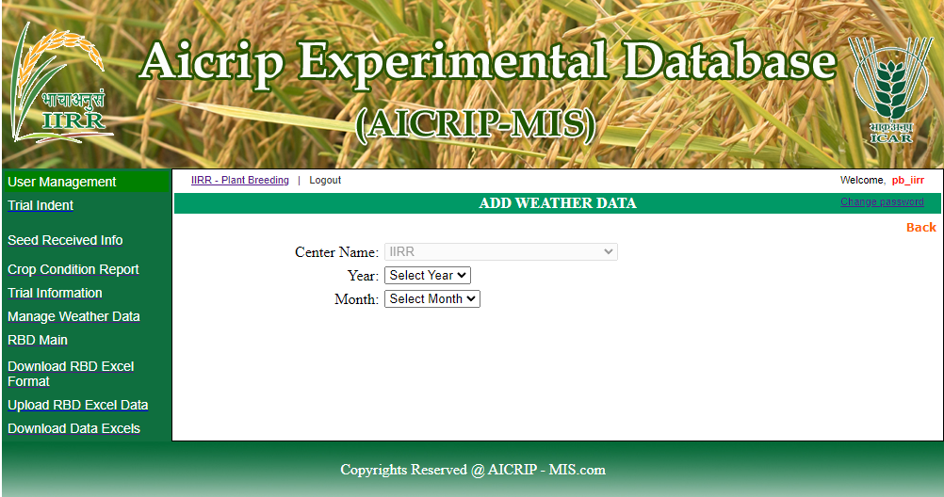

First user has to select year and month from drop down box then use the copy from Excel option to copy and paste data in the Excel interface. Then copy and paste data as per the order of parameters displayed in the sample sheet. By using Click hear to copy data from Grid button, the data will be copied to the grid. The data will be saved in the server database by using Add button.

